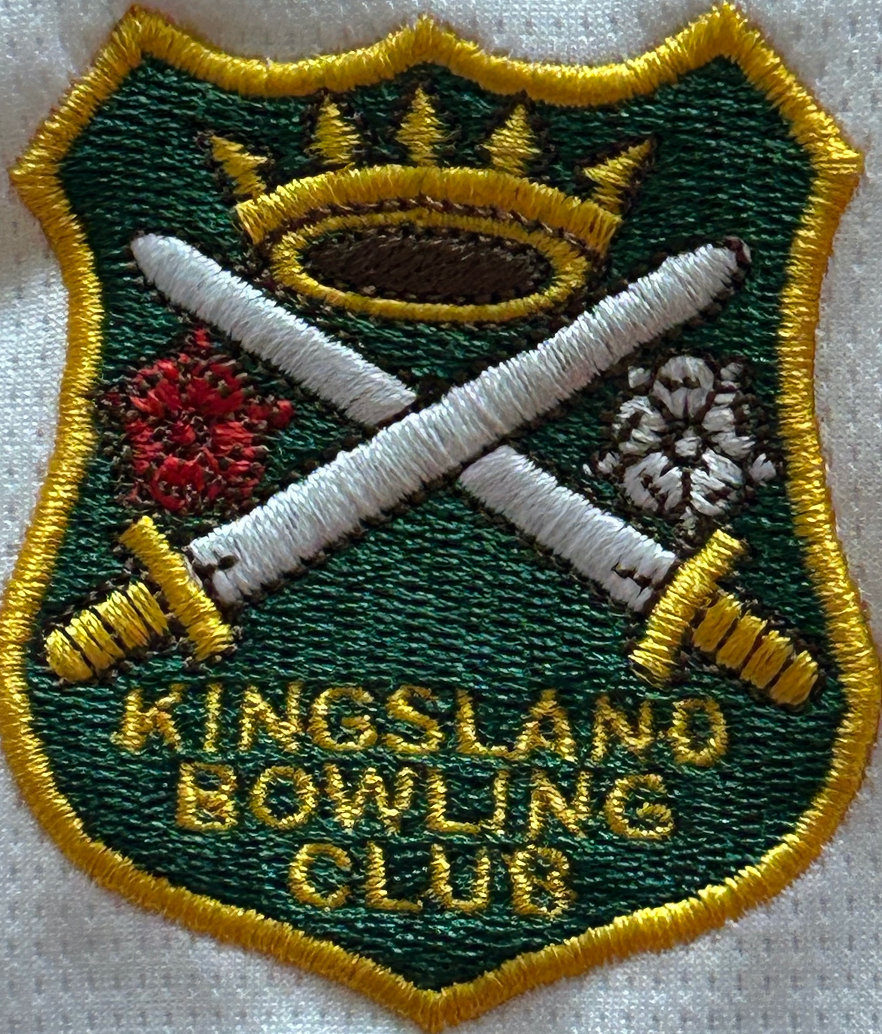
News From The Green Newsletter of
Kingsland Bowls Club

January 2025

Edition 3

Whilst it’s closed season for most, the Executive Committee continues in its preparation for the 2025 season. The monthly meetings keep coming round, (I’m sure they're more than Monthly!!), with red hot phones and mailboxes fit to burst. Margaret Read has set up a fantastic season of matches, Tarmac League, friendlies, internal competitions and County matches, still not sure how she's fitted so much into such a short season.
Stuart has also been hard at it, working with Margaret to fit in all our knock-out and one-day competitions. Ian C is keeping the estate running ensuring the building is frost free, and that the problems we saw last year with our water supply are finally sorted. Graham has been keeping an eye on membership subscriptions trickling in, we will shortly be contacted by Bowls Hereford to confirm our membership numbers and pay our £10 per head subscription to them, so please pay up sooner rather than later!
The Social and Catering Teams, under Jane Airey and Jayne Cooper have been doing a wonderful job all winter, keeping us entertained and fed every other Friday, with the next one being horse racing on the 21st February (remember the quiz on the 7th had to be cancelled). The coffee morning on the 6th is still going ahead. Chris Read has the bar well stocked and is waiting for your orders.
Jan Moore has been revisiting many of our policies with help from Terry; these will be available on the club website and as hard copies in the clubhouse. Please ensure you make yourselves aware of these, they really are an important part of club membership, and tell us how we should behave as members and how we should expect other members to behave towards us.
Simon and Pat have been flying the Kingsland flag at indoor bowls in Leominster, as well as representing the club at mens and ladies county meetings. Work is already under way preparing the green for the start of the season.
Peter Moore, Susanna, Terry and I have been looking at ensuring the longevity of the club; many clubs around are closing with increased costs associated with the running of a club coupled with decreasing membership.
I, for my sins, have re-written the dress code, (I’ve attached a copy to this email). There are also laminated copies on the general noticeboard, mens/ ladies noticeboard, and competitions noticeboard. The notice boards in the clubs have been re-allocated, so please acquaint yourselves with the new layout next time you’re in the clubhouse.
Trish and I spent our afternoons watching the World Indoor Bowls competitions from Potters Bowls Resort last week, If you didn’t see any of it, you missed a treat, it was fantastic. But it did make me think about indoor bowling thats available to us. This led me to contact Pat Davies to give us an invite into whats going on and how our teams are doing.
Pat said: Indoor bowling is addictive!
Kingsland entered the Indoor/ outdoor league which started in October. We play 2 rinks of triples on a Monday evening and have a pool of 13 players that rotate in a (sometimes haphazard ) way depending on availability. This is a great place to start playing indoor bowls. The Kingsland team is holding its own currently being joint third out of 7 clubs.
There are also training sessions run through the winter, mostly every other Saturday, which occasionally gets changed to a Sunday, (look on the Bowls Hereford website under Coaching for further info). These sessions cost £3 per session (and £1 to park at the leisure centre) and are between 10:00- 12:00 The first hour is for training the second hour usually becomes a bit of a friendly competition. This is a great way to get into indoor bowls without the commitment of joining in a competition. You do need your bowls shoes, and bowls, its a really friendly atmosphere and the skills you pick up are easily transferable into the outdoor game.
Some of our more experienced players are involved in the Thursday morning and evening leagues. These cost £6.25 per match, it is fun, but with a bit more determination involved. We have two teams, ‘The Follies’ and
‘Leominster Laundry’ (I think they're hoping to clean up!!!) (sorry)
currently we stand
Tuesday evening. Leominster Laundry 4th out of 7
Thursday morning. Follies 7th out of 7
Thursday evening. Leominster Laundry 2nd out of 8
Follies 4th out of 8
So well done to both teams.
Thanks Pat

Next edition out February ’25

